**CSC 250 – Program 6 Design Document**

**John Akujobi**

**Structure Chart**

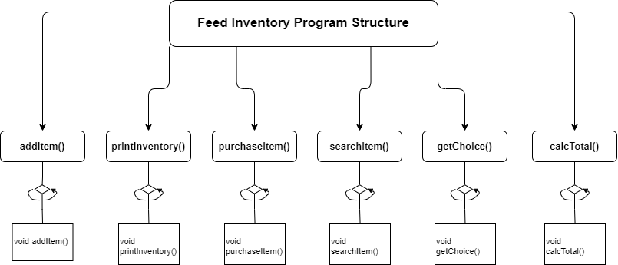

**Function Design**

Note: I made all the functions so they do not need to take in values and have their own declared objects used within

1. **addItem()** - Add a new item to the inventory.
   * void addItem();
   * Asks the user for the name of the item, quantity in bags, and price per bag. Then it creates a new object with the input data and appends it to the end of the "feed.dat" file.
2. **printInventory()** - Print the information for all items in table form.
   * void printInventory();
   * Reads all the structures in the "feed.dat" file and displays the information for all items in a well-organized table format.
3. **purchaseItem()** - Buy’s an item by name and quantity.
   * void purchaseItem();
   * Asks the user for the name of the item and the quantity to purchase. Then it searches for the record that matches the name, updates the quantity, and writes the updated inventory back over the original one.
4. **calcTotal()** - Function to calculate and display the total value of the items on hand.
   * void calcTotal();
   * Reads all the structures in the "feed.dat" file and calculates the total value of the items on hand. It then displays the result to the user.
5. **searchItem()** - Function to search for an item by name.
   * void searchItem();
   * Asks user to input the full or partial name of the item to search for. Then it searches for the record that matches the name and displays the information for the item.
6. **getChoice()** - Function to get the operation choice from the user.
   * int getChoice();
   * Displays the operations menu to the user and prompts them to input their choice. Uses the enum type then returns the user's choice as an integer.

**Time Estimate**

|  |  |  |
| --- | --- | --- |
| **Function Name** | **Estimated Time** | **Actual Time** |
| Program Design | 60 mins | 45 mins |
| (list each function name and the time required to code each) |  |  |
| addItem() | 20 mins |  |
| printInventory() | 20 mins |  |
| purchaseItem() | 20 mins |  |
| searchItem() | 20 mins |  |
| main() | 40 mins |  |
| Program Test | 30 |  |
| **Total Time** | 210 mins |  |